Searching for local items and placing holds for curbside pick-up

- Currently curbside pick-up is limited to materials owned by the pick-up location.
- There may be delays in filling requests as libraries adjust to the temporary curbside service model.

- Go to the V-Cat Classic catalog: https://catalog.wvls.org/
- Select the library where you would like to pick up materials in the drop down menu.
  - Check to see that the library is open BY APPOINTMENT and not CLOSED.
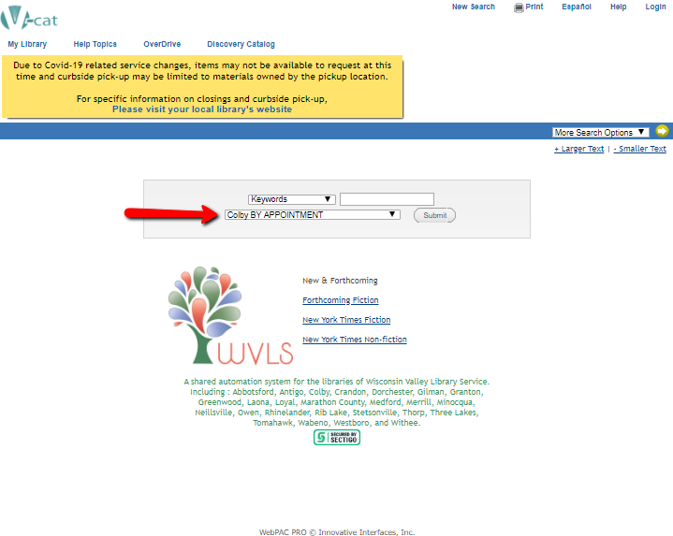
- Begin your search.

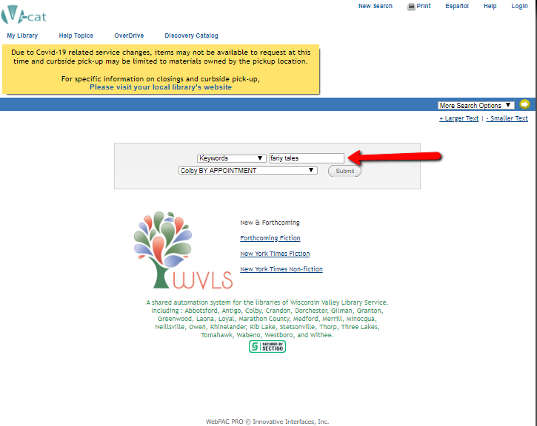
- Locate an item you would like to request.
- Verify that the item is "available" at the library where you wish to pick up your items.
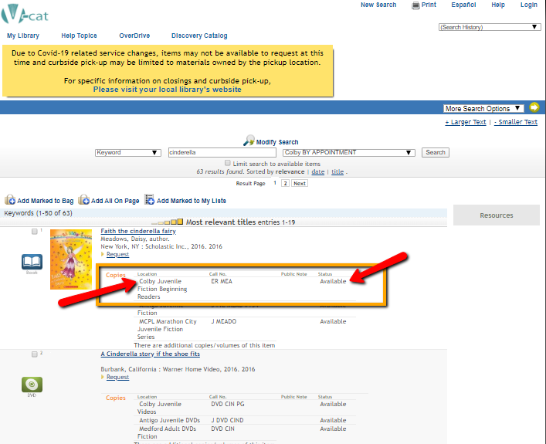
- Click “Request”
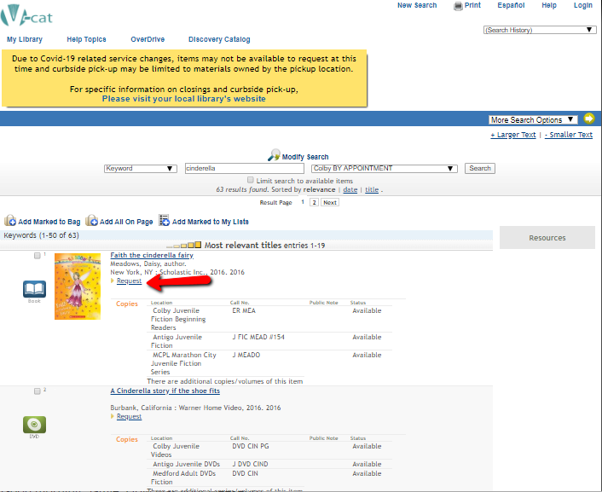

- Enter your library card number and pin number (usually the last 4 digits of your phone number).
- Click ‘Submit’

- Select the pickup library.
- Click “Submit”.
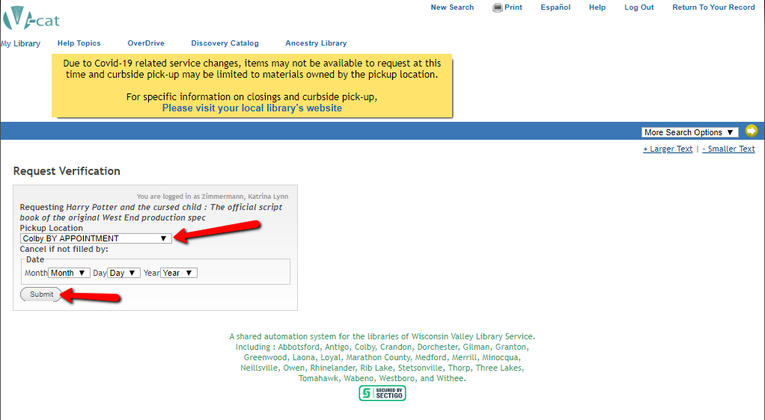
- To continue searching, click on Regular Display followed by Return to Browse to return to your first list of search results OR click on New Search to start a new search. (With new search the library you chose in step 2 should still appear, but it is a good idea to double check.)

- Wait to hear from your library that materials are ready and schedule an appointment for pick-up.

