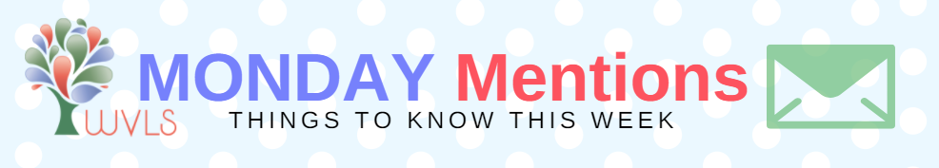

1. Upcoming CE
10 a.m., Thursday, June 7: Dealing with Substance-Abusing Patrons in the Library: From Meth to Marijuana, Opiates to Alcohol (webinar); Register

2. Recent Digital Lites Posts
- FBI Advising U.S. Citizens to Reboot Routers
- WAPL Conference Recap: Keynote on Kindness

3. WLA 2018 Awards: Now Accepting Applications
Honor the innovative and exceptional library services, staff, trustees, and supporters in Wisconsin. Nominate an individual, group, or library for one of the 2018 WLA Awards with the streamlined application process. Applications are due on September 1.

Visit the WLA website for a list of awards or see the list below. The criteria, application form, and instructions to apply are listed under each individual award on the website. Winners will be honored at the WLA Conference in La Crosse during the Awards and Honors Reception.
Questions? Contact Karli Pederson, Awards and Honors Committee Chair.

4. State Library News & Resources
- Michael Dennison joins Public Library Development from the Title I and School Support Team within the Department of Public Instruction. He has extensive knowledge and experience in federal and state grant reporting and has served the agency as a grants specialist. Read More.
- Registration is now open for the Charlotte Zolotow Symposium: Illuminating Experience on Saturday, October 13, at the Pyle Center at UW-Madison. Early bird registration is $75. More information and to register.
- The recording of last week's webinar with BiblioBoard on Pressbooks and SELF-e can be found here.

5. PLSR Updates
- The PLSR Steering Committee and Core Recommendation Collaborators will meet Friday, June 8, beginning at 9:00 a.m. at the Portage County Public Library in Stevens Point. The agenda is available on the PLSR site. The public may attend in-person.
- May Highlights are now posted on the PLSR website.

6. Future Conferences (Repeat)
- WiLSWorld 2018 Registration is open, for July 25-26, in Madison. More information.
- 2018 Back in Circulation Again Conference, October 15-16, in Madison. More information and to register.

Have a great week!

