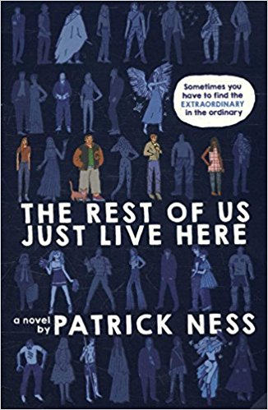
BOOK BLURB:

“NOT everyone HAS TO BE THE chosen ONE
What if you’re not an indie kid, fighting zombies or whatever this new thing is with the blue lights and the death?
What if you’re like Mikey? Who just wants to graduate before someone blows up the high school. Again.
Sometimes you just have to discover how even an ordinary life can be extraordinary.”
PatrickNess.com

